Statistical parameters of the grading curves and soil parameters
By Lizeth Guadalupe Lamas Lopez in 2021
Supervisor: Mészárosné Ph.D. Ágnes Bálint Ph.D.

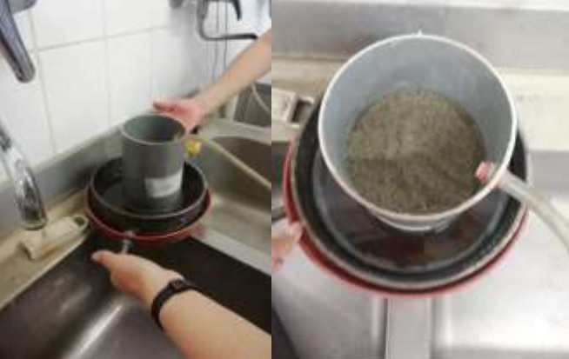

In this work, 15 laboratory permeability tests are made for saturated permeability on fractally distributed sand mixtures (which are mean grading curves with predetermined composition). The linear regression of the measured k with both the well-established (d10, void ratio e and Kozeny term) and the new (grading entropy type) variables of the grading curves are studied.

According to the results with the simulated data, the R2 value of the correlation was high and were improved if the entropy variables combined with the well-accepted e and d variables. However, the results indicated that the preciseness was better if only the data of non-segregating, internally stable mixtures are used, indicating the importance of selecting non-segregating mixtures in laboratory tests. The results with the average data differed slightly.

In the next stage of the research, more precise k measurement will be suggested, by building-up the samples with wet tamping and waiting until the water flow is steadystate.

