Comparative Analysis on Biomass Binding Capacity of Biofilm Carrier Media for Biofor™ Biofiltration System
By Baatar Anar in 2021
Supervisor: Rita Bodáné-Kendrovics Ph.D.

During the course of the work, main growth types of biofilm were discussed, which later helped categorize biological treatment systems currently being used nowadays. With this, biofilm formation and functioning were presented along with media carriers. All of this led to the topic of an effective choice of the carrier in a given system.
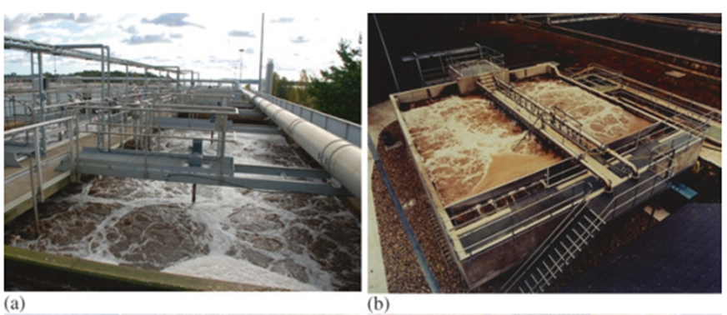
Based on the result of the experiment, it was shown that if there are given several choices of carriers and priority lies in the ability of biofilm adhesion among a few factors such as abrasion and water-binding capacity, proper carrier media could be chosen by identifying the amount of biofilm attached on the surface of carriers through respiratory activity. In this case, this study was carried out in accordance with submerged ﬁxed bed bioﬁlm reactor of Biofor™ at South-Pest wastewater treatment plant.
In the respiratory test, depending on determination and comparison of many factors including the amount of biofilm community, indirect amount of biomass, significant increases in oxygen uptake rates and respiration rate of samples along with synthetic sewage under appropriate consideration of contact time and exposure scenario, the desired carrier was chosen and its size distribution and spacing were sufficiently uniform.
A single selection of competitive media carrier over its counterparts does not stop at mere selection but it shows how complex activities of microorganisms, bacteria, and many more components are involved and analyzed in such selection that will go on to benefit the maintenance and efficiency of the wastewater treatment plant, and sure to be an economically wise decision for its operating entity.

