Environmental footprint of textile industry
By Boldbaatar Tsendsuren in 2021
Supervisor: Edit Csanák Ph.D.

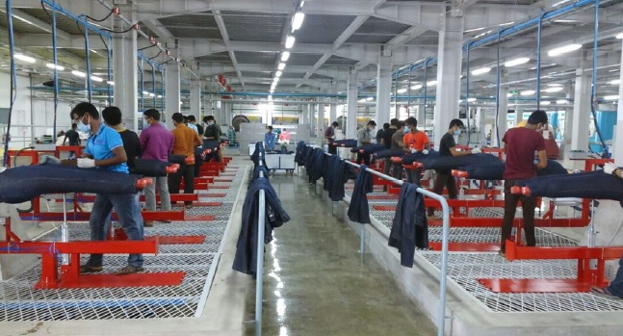
This project aimed to analyse the environmental issues related to the textile industry. Its goal was to investigate the economic, technological, and social factors related to the textile industry and its ecological footprint on a deeper level. Also, the Authors intention was to elaborate on the latest good practices applied in the textile industry used to minimalize the Industry's environmental impact. Working on this project helped me improve my academic writing skill, interviewing skills, data collection, sorting, and organization, and gaining proper knowledge on the topic of the environmental footprint of the textile industry. Furthermore, researching such a topic influenced my perspective on fast fashion, greenwashing, and my personal choice of clothing and usage.
The textile industry is not just a sector related to clothing production. Still, many industrial and technical production is associated with the production of garments and apparel, and therefore, the problems never cease to end. However, consumers are being educated about textile materials, the hidden truth behind the production process, and the impact on the earth, which can contribute to their fashion choices.
In conclusion, in my dissertation, I managed to present innovative initiatives to reduce the environmental footprint of the textile industry, develop and deepen my environmentally conscious approach, and enrich my knowledge in a separate area of the Industry. Therefore, I am confident that my thesis research work will be put into practice, and I will continue my work in this research field as a professional.

