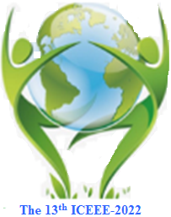 |  | The 13th ICEEE-2022 Online  International Annual Conference on  “Global Environmental Development & Sustainability: Research, Engineering & Management”

Date: 17th – 18th of November 2022, 9:00 a.m.

Location: Óbuda University. Budapest – Hungary

Application deadline: October 15th, 2022.

Please send the completed application form to bayoumi.hosam@uni-obuda.hu.

Please fill out the application form by machine!
First name:
Last (Family) name:
Nationality:
Workplace: University/Organization
Title: Mr. / Ms. / Miss
Eng. PhD student Dr. Prof
Academic Position:
Professional field (Specialty)
Qualification
Presentation type (Oral / Poster)
1st presentation (oral /poster) title:
Author(s)
2nd presentation (oral/poster) title:
Author(s)
Mailing address | Recipient name
 | City, Country
 | Street, building number
 | Postal code
E-mail:
Telephone/Mobile:
Selected Session  Please underline your session |  |  | Session (A) Healthcare: Risk & Management:  Session (B) Soil Biology & Land Uses  Session (C) Physicochemical Properties of Water & Sediments  Session (D) Circular Economy Strategy and Waste Management:  Session (E) Waste Management  Session (F) Atmospheric Pollution Assessment:  Session (G) Ecosystems & Landscape for Future Generations:  Session (H) Environmental Sciences:  Session (I) Natural Sciences:  Session (J) Sustainable Energy Research & Applications:  Session (K) Effects of Sustainable Development on:

