The 13th ICEEE-2022 Online

International Annual Conference on
“Global Environmental Development & Sustainability: Research, Engineering & Management”

TITLE Font: Times New Roman; Size: 14; Central
Author NAME¹ Font: Times New Roman; Size: 12; Central
^{1*}Workplace, city, country, e-mail, telephone Font: Times New Roman; Size: 11; Central
Abstract. maximum 250 words
Concise and factual. It should state briefly the purpose of the research, the principal results and major conclusions.
100 to 300 words;
No figures; Avoid numerical references
Sub-sections if needed.
The abstract should be written in English;
Font: Times New Roman, Size: 10, Alignment: Justified

Keywords: max. 6 words
INTRODUCTION
Mention the most important literature survey

The article should be composed of Title, Abstract, Keywords, Abbreviations, Introduction, Main body, Conclusions, References, Acknowledgments and Reference.
The article should be written in English;
The article should be at least 3 pages, and can be extended to 25 pages depending on the type of research.
Font: Times New Roman, Size: 11, Alignment: Justified

The main text must be clearly paragraphed. State the objectives of the work and provide an adequate background, comprehensive insight on the purpose of the study and its significance, avoiding a detailed literature survey or a summary of the results.

MATERIALS AND METHODS
Mention the most important materials and
Write down briefly, the method(s) used
This section may be divided by subheadings, sub-sub headings. Provide sufficient details to allow the work to be reproduced by an independent researcher.
Methods that are already published should be summarized, and indicated by a reference. Any modifications to existing methods should also be described.

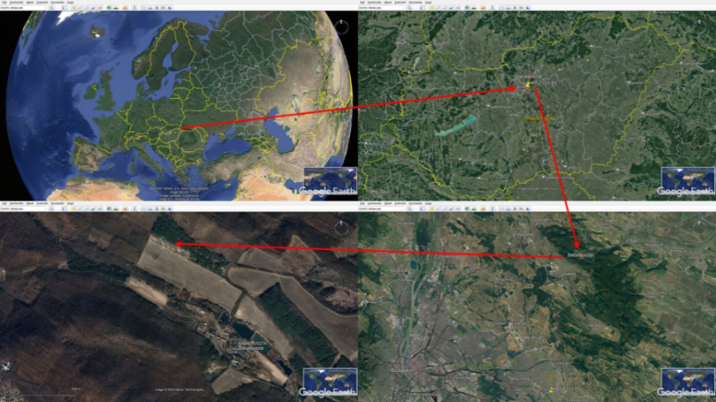

Figure 1. Situation of the sampling sites of the mole burrows in the Babat Valley
(Source: Google Earth)
Table 1. Title of the Table
S. No | Ingredients | Percentages | Results or any
1
2

STATISTICAL ANALYSIS
RESULTS AND DISCUSSION
Results should be clear and concise and also separate from the Discussion part. Each Tables and Figures must be found below their respective paragraphs from the Results part.
This should explore the significance of the results of the work.

CONCLUSIONS AND RECOMMENDATIONS
Conclusion should elucidate how the results communicate to the theory presented as the basis of the study and provide a concise explanation of the allegation of the findings.

ACKNOWLEDGMENTS
Collate acknowledgments in a separate section at the end of the article before the references. List here those individuals who provided help during the research.

REFERENCES
All references should be cited in the article in a consecutive order and ensure that every reference cited in the text is also present in the reference list (and vice versa).

List here all the references in numbered order of citation in the text. If more than three authors, list the first three followed by “et.al.”
Font: Times New Roman; Size: 11; Alignment: Justified

[1]
[2]
[3]
[4]
[5]
[6]
[7]

Figures
Figures should be clear with high resolution. Figure caption should be provided in editable format and outside of a picture.
If figures are used from any other source, authors are responsible to secure permission for copy right.

Font: Times New Roman; Size: 10; Alignment: Left
Note*: Preferred formats JPEG/PNG

Tables
Tables must be in editable format and numbered in order with clear annotations. Each table must include a brief descriptive title and headings for columns and rows.
No image format in tables.
Table Abbreviations: Give full form of all abbreviations used in the table even if it has been explained in the text.

