Study on the Adsorption of Pesticides in Sediment and Soil particles in Water Systems
By Ganbat Mungunzaya in 2021
Supervisor: Rita Bodáné-Kendrovics Ph.D.

This study attempts to simulate after scenario of the application with pesticides in the water-soil/sediment system. Determination of time to reach equilibrium for individual pesticides was of significant interest in this study. Another important goal of this thesis was to measure the adsorption of pesticides onto soil and sediment particles. In general, the adsorption process illustrates the movement of a solute from an aqueous phase to a solid phase. Moreover, adsorption is directly connected to the mobility of pesticides in the solid phase and leaching potential to groundwater. It is important to study this process in connection to the soil/sediment parameters such as organic matter content. Therefore, 5 polar neonicotinoids in one solution and 5 pesticides with different polarities in one solution at a concentration of 2 µg/mL were separately added into the 200mL of Danube River water, and then 10g of soil/sediment was added.
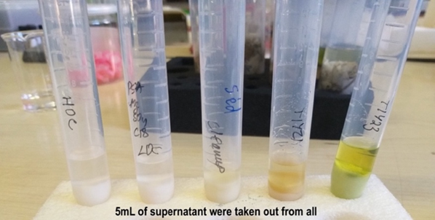
These water-soil/sediment solutions containing the pesticides were slowly stirred for 24 hours to reach equilibrium and later analyzed with HPLC-UV. Neonicotinoids were completed with five soils and four sediments using QuEChERS method for the solid-phase extraction. The second investigation with the other five 5 pesticides was only completed using four 4 soils with a different modified solid-liquid extraction method. Therefore, moisture content, pH, and temperature will be considered for further research.
Three phases were analyzed, water, solid, and paper phase. The amount determined in a solid and paper phase were at closer levels to each other. Depending on the test substance’s water solubility and LogP value, we could expect the distribution of pesticides between the phases. So far, the distribution coefficient for adsorption Kd, and adsorption percentage at equilibrium were calculated.
Neonicotinoids were almost entirely found in the water phase. Therefore, the amount sorbed to soil and sediment particles was low. Their Kd values showed low values as well. However, in accordance with our expectations, TCL showed the highest adsorption to soil and sediment with high organic matter content. For the pesticides with different LogP values, TFL and TRF showed the highest adsorption to soils with high organic matter content while the remaining three pesticides TRB, DMA, ATC were found in the water phase at high concentrations. The following correlation was observed: high organic matter content and high LogP value, and low water solubility showed high adsorption value for the pesticides.

