Surface water treatment and quality control in Morocco

By Ait Mansour El Mehdi in 2020

Supervisor: Rita Bodáné-Kendrovics Ph.D.

The Bouregreg treatment plant performs the treatment and control of water quality by various physicochemical, bacteriological, and organoleptic processes. Indeed, it plays a role of paramount importance by the water supply of the largest economic and social centers.
The drinking water production program conducted by ONEP within the Bouregreg complex focuses on the choice of the level of raw water intake, artificial delamination by aeration, and the use of silver carp to combat the eutrophication of the waters of the Bouregreg reservoir.

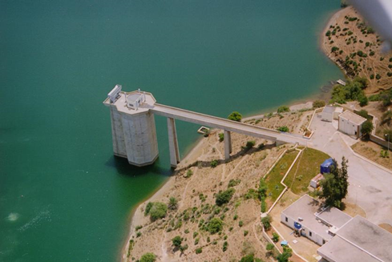

This is coupled with the choice of the nature and dosages of the treatment reagents by the Jar Test. This program has led to an improvement in the quality of the raw water and has made it possible to produce water that meets the standards of potability described by the Moroccan standard 03.7.001.
ONEP undertakes huge investments to guarantee the production of quality water. Thus, it is our duty as citizens to fight against pollution and waste.

