The effects of water pollution on the amount of oxygen present in the atmosphere

By Nadaprapha Binsa Aeteh in 2021
Supervisor: Rita Bodáné-Kendrovics Ph.D.

As pollution problems are becoming more aware and enlightened by many people, it is important that other problems related to the environment caused by pollution are also being considered.
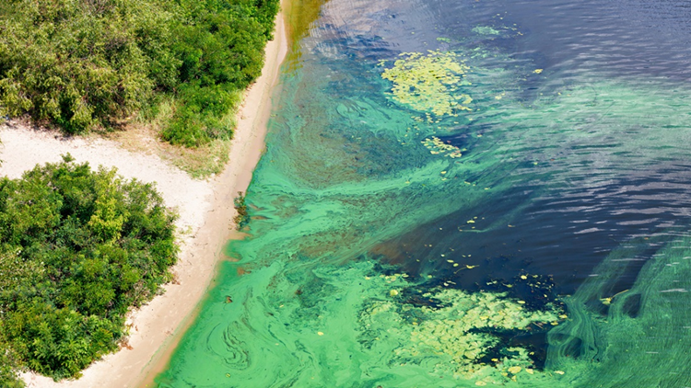
The findings and results of this study yield that the marine pollutions caused by anthropogenic activities from land-based sources create adverse effects on the water quality of oceans, seabed, marine organisms, human health, and human economy and society. Furthermore, marine pollutions lead to many processes include ocean acidification, harmful algal blooms, ocean deoxygenation, hypoxia, and oxygen minimum zones, which are dangerous for marine ecosystems because these processes could damage and kill many species, affect marine biodiversity, and most importantly, could impact photosynthesis efficiency of the organisms that are responsible for the oxygen production. Future research into the effects of marine pollutions on the amount of oxygen present in the atmosphere should focus on establishing clearer results of how much oxygen is being released to the atmosphere in the polluted areas. Additionally, observational studies of the amount of oxygen present in the water bodies are required to gain more insight into the topic. This would help to expand the area of human understanding about pollution.
Before all water bodies are polluted to the point that no oxygen could be produced, it is important that global citizens are aware of how their behaviour indirectly affect not only human but also other organisms’ health, habitat, and ecosystems. We, the global citizens, are responsible for the pollution in the world and we should be the ones to save and restore the marine ecosystem, and other polluted ecosystems, back to normal – or at least not polluting them more. Cooperation from governments, the business sector, organizations, researchers, scientists, and every global citizen to reduce, reuse, and recycle will help to save the oceans and the environment.

